

Telephone Circuits and Switches

**Report two**

**Hardware Implementation of GPS Tracking System Using SIM808 module**

**Students Names:**

Abdelrahman Shrief - Ali Osama - Sondos Reda - Mohamed Alaa Mohamed Ramadan - Ahmed Ayman - Ahmed Tarek

**Supervisors:**

Dr. Mohamed Hamdy El-Saify

Eng. Ahmed Fathy

# Objective:

# The objective of the GPS Tracking System Via SMS Using SIM808 project is to develop a cost-effective and accessible solution for real-time tracking of objects or vehicles. By leveraging the SIM808 module's GSM capabilities, the project aims to enable remote monitoring of location via SMS, ensuring reliability and ease of use without the need for internet connectivity. The system should offer customization options, ensuring it meets specific tracking requirements while prioritizing security measures to safeguard location data and prevent unauthorized access.

# Introduction:

Real-time asset tracking and monitoring has become essential for many industries and daily life in an era where people and goods are constantly moving. Having timely access to location data has become essential for a variety of tasks, including fleet management, equipment protection, and family safety. However, conventional GPS tracking solutions might not work well in situations where internet connectivity is spotty or nonexistent. Use SMS to Access the GPS Tracking System Using the SIM808 project, a ground-breaking initiative that sought to close this gap by utilizing SMS communication enabled by the SIM808 module and the power of Global Positioning System (GPS) technology.

This project, at its core, is an example of innovation and pragmatism coming together to provide a reliable and reasonably priced remote tracking and monitoring solution. The SIM808 module functions as the principal component of the system, facilitating the smooth integration of GPS positioning with GSM communication. This allows users to obtain real-time asset location updates through straightforward SMS commands.

This project is important because it is accessible and easy to use, in addition to being technically inventive. The GPS Tracking System Via SMS Using SIM808 project is made to be simple, as opposed to complicated tracking systems that call for complicated setup procedures or specialized knowledge. Users can easily interact with the tracking device with only a basic understanding of SMS messaging, making it available to a wide range of people and industries.

Furthermore, there are no limits to this system's versatility. There are many uses for this technology, ranging from fleet management and coordination optimization to personal vehicle security and other areas. The GPS Tracking System Via SMS Using SIM808 project provides a customized solution for any tracking need, be it tracking the whereabouts of valuable equipment, monitoring the movements of a delivery truck, or guaranteeing the safety of a lone traveler.

Moreover, the project prioritizes accuracy and dependability. By utilizing GPS technology's pinpoint accuracy, the system provides users with up-to-date, actionable location information in real-time. Further improving the tracking device's usefulness and efficacy are customization features like geo-fencing, regular location updates, and emergency alerts, which let users tailor the device to meet their unique needs.

The GPS Tracking System Via SMS Using SIM808 project does not cut any corners when it comes to security. To protect against unauthorized access and guarantee the integrity and confidentiality of location data, strong encryption protocols and access controls are put in place. The project gives users confidence by emphasizing security and reassuring them that their assets are safe from potential threats or breaches.

In conclusion, a change in thinking in the field of tracking and monitoring technology can be seen in the GPS Tracking System Via SMS Using SIM808 project. It provides a flexible, affordable, and easily integrable solution for a wide range of tracking applications by fusing GPS positioning with SMS messaging. This project has the potential to completely change how we track and monitor assets in situations where internet connectivity is scarce or unpredictable because of its emphasis on simplicity, dependability, versatility, and security. The GPS Tracking System Via SMS Using SIM808 project is a shining example of innovation in an increasingly dynamic and connected world, enabling both individuals and industries to stay informed, safe, and in control.

# Circuit Diagram and software:

In the next figure you can see the connection between Arduino uno and SIM808 module in the next circuit diagram.

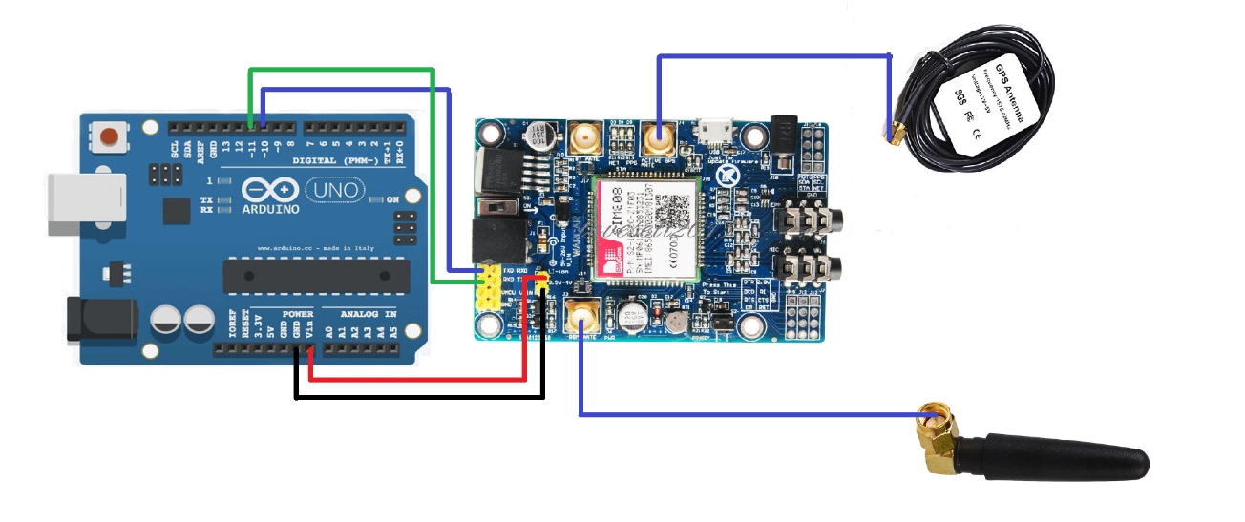

Figure 1 Crcuit Digram

**The Arduino Uno** is a popular microcontroller board based on the ATmega328P chip. It is the most widely used Arduino board due to its simplicity and versatility.

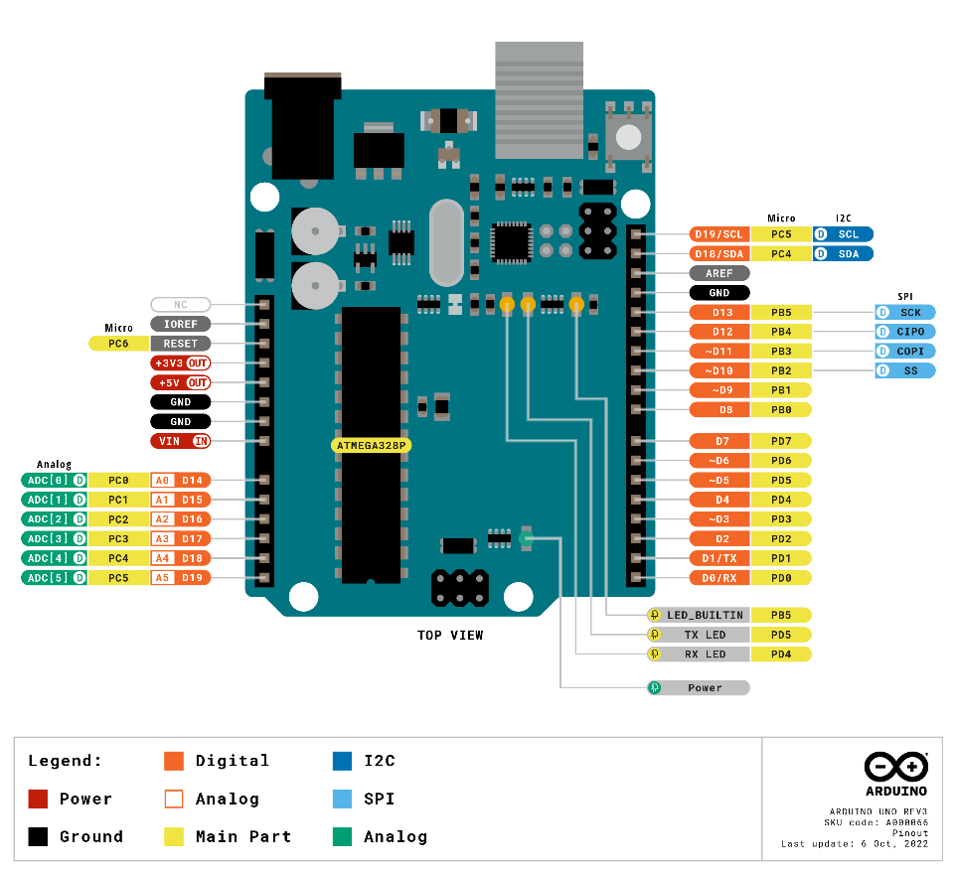

Figure 2 Arduino Uno PINOUT

Here is a concise overview:

1. **Microcontroller**: The heart of the Arduino Uno is the ATmega328P microcontroller, which runs at 16 MHz and has 32 KB of flash memory for storing code and 2 KB of RAM for data storage.
2. **Digital and Analog I/O:** The Uno features fourteen digital input/output pins, of which six can be used as PWM (Pulse Width Modulation) outputs, and six analog input pins. These pins allow interfacing with various sensors, actuators, and other electronic components.
3. **USB Interface**: The Uno can be easily connected to a computer via USB, allowing for programming and serial communication. It uses a standard USB Type-B connector.
4. **Power Options**: The board can be powered via USB connection or an external power supply (7-12V DC). It also has a built-in voltage regulator, allowing it to be powered directly from a 5V source.
5. **Integrated Development Environment (IDE)**: Arduino Uno is programmed using the Arduino IDE, a user-friendly software environment that simplifies coding and uploading sketches (programs) to the board.
6. **Open-Source Platform**: Arduino Uno is part of the Arduino ecosystem, which is open-source. This means the hardware designs, software, and documentation are freely available, encouraging collaboration and innovation among the community.

Overall, the Arduino Uno is a versatile and beginner-friendly platform for electronics projects, ranging from simple blinking LED experiments to complex automation and robotics projects. Its ease of use, extensive community support, and vast array of compatible sensors and shields make it a favorite among hobbyists, educators, and professionals alike.

**The SIM808** is a versatile GSM/GPRS and GPS module that combines communication and positioning functionalities into a single compact package. Here is an explanation of the SIM808 module along with GSM and GPS antennas:

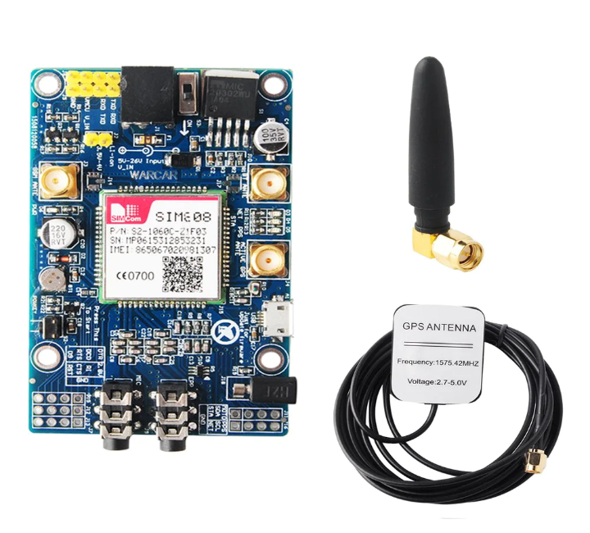

Figure 3 SIM808 Module With GPS/GSM Antenna

1. **SIM808 Module:**
   * The SIM808 module is a small electronic device that integrates GSM/GPRS (Global System for Mobile Communications/General Packet Radio Service) and GPS (Global Positioning System) functionalities into a single module.
   * It is typically used in projects requiring cellular connectivity for communication purposes (such as making calls, sending SMS, or connecting to the internet via GPRS) and GPS functionality for location tracking or navigation.
2. **GSM Antenna:**
   * The GSM antenna is used to transmit and receive GSM signals. These signals are essential for establishing communication with mobile networks, allowing the SIM808 module to make calls, send SMS messages, and connect to the internet via GPRS.
   * The GSM antenna is typically connected to the SIM808 module via an SMA or U. FL connector, depending on the module's design.
   * It is important to choose an appropriate GSM antenna with suitable gain and frequency characteristics to ensure optimal performance and reliable communication with mobile networks.
3. **GPS Antenna:**
   * The GPS antenna is used to receive signals from GPS satellites to determine the module's precise location on Earth.
   * These signals contain timing and positioning information, which the SIM808 module processes to calculate its latitude, longitude, altitude, and other location-related data.
   * The GPS antenna is also typically connected to the SIM808 module via an SMA or U. FL connector.
   * Like the GSM antenna, selecting the right GPS antenna with good sensitivity and coverage is crucial for accurate and reliable GPS positioning.

In summary, the SIM808 module, along with GSM and GPS antennas, provides a comprehensive solution for projects requiring both cellular communication capabilities and GPS-based location tracking or navigation. Together, they enable a wide range of applications, from vehicle tracking systems and asset management to IoT devices and remote monitoring solutions.

**Overall Functionality of The Code:**

The code is designed to interface with a SIM808 module, which is a GSM/GPS module, using an Arduino board. It enables the Arduino to send and receive SMS messages, retrieve GPS data, and perform actions based on received messages.

**Detailed Functionality:**

1. Initialization Function **setup ()**:

* Serial Communication Setup:
  + Initializes serial communication between the Arduino board and the computer for debugging purposes.
  + Initializes serial communication between the Arduino board and the SIM808 module for sending and receiving AT commands and SMS messages.
* SIM808 Module Initialization:
  + Calls the **InitSIM808()** function to configure the SIM808 module.
* Initialization SMS:
  + Sends an SMS to a predefined phone number to indicate that the SIM808 module is ready for use.

1. Main Loop Function **loop ()**:

* Listening for Incoming Messages:
  + Continuously listens for incoming messages or calls from the SIM808 module.
  + If an SMS message is received, it triggers the **processOnSMSMessage ()** function to manage the message.
  + If a new call event is detected, it retrieves GPS data and sends an SMS containing the location details.

1. SIM808 Module Initialization **InitSIM808():**

* AT Commands Initialization:
  + Sends various AT commands to the SIM808 module to initialize and configure its settings.
  + Ensures that the SIM808 module is responsive and properly configured for subsequent operations.

1. Waiting for SIM808 Response **WaitForRespSIM808():**

* Waiting Loop:
  + Enter a loop to continuously wait for a response from the SIM808 module.
  + Waits until the received response contains a specified keyword or until an error condition is encountered.

1. Sending AT Commands to SIM808 **SendComToSIM808():**

* AT Command Transmission:
  + Sends AT commands to the SIM808 module via the Software Serial interface.
  + Waits for the module to process the command and provide a response.
  + Returns the response received from the SIM808 module.

1. Sending AT Commands and Checking Response **SendComToSIM808AndCheckForResp ():**

* AT Command Verification:
  + Sends AT commands to the SIM808 module and verifies the response against an expected result.
  + Returns a Boolean value indicating whether the response matches the expected result.

1. Conversion from DDM to DD **ddm_to_dd ():**

* Coordinate Conversion:
  + Converts latitude and longitude coordinates from degrees decimal minutes (DDM) format to decimal degrees (DD) format.
  + Allows for easier manipulation and representation of GPS coordinates.

1. Retrieving GPS Data **getGPSDataFromSIM808():**

* GPS Status Check:
  + Sends commands to the SIM808 module to check the status of GPS data availability.
  + If GPS data is available, retrieves raw GPS information and parses it to extract latitude and longitude coordinates.

1. Sending SMS Messages **sendSMSUsingSIM808():**

* SMS Transmission:
  + Sends SMS messages to specified phone numbers via the SIM808 module.
  + Ensures that the message is successfully delivered by waiting for acknowledgment from the module.

1. Processing Incoming SMS Messages **processOnSMSMessage ():**

* SMS Message Handling:
  + Processes incoming SMS messages based on predefined keywords and commands.
  + Executes actions such as requesting GPS data, making calls, or managing emergency messages.

1. Making Calls **makeCallUsingSIM808():**

* Call Initiation:
  + Initiates outgoing calls to specified phone numbers via the SIM808 module.
  + Waits for acknowledgment from the module before terminating the call.

In the next figure the overall flowchart of the Arduino code:

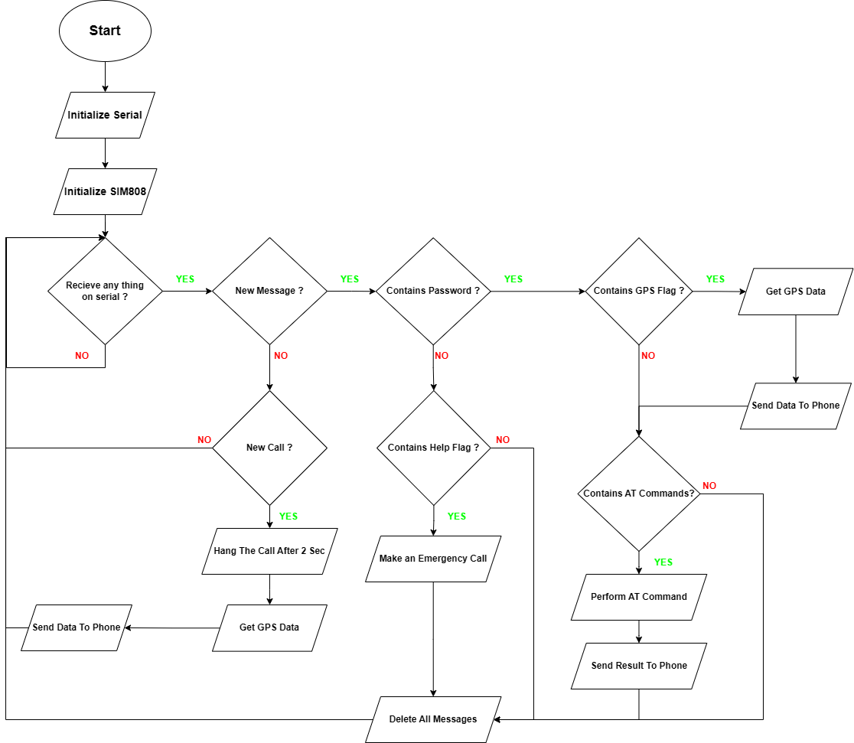

Figure 4 Flow Chart Of The Arduino Code

# Results and Testing:

This section presents the components utilized in the hardware circuit :

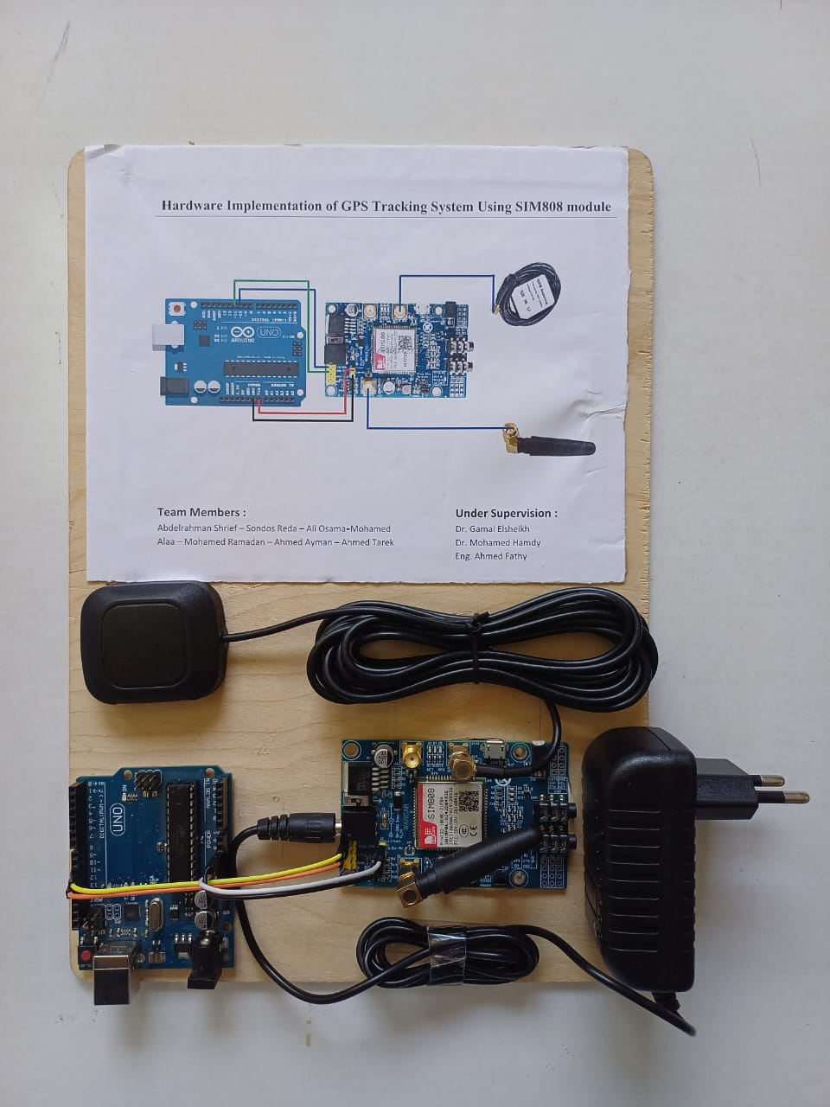

Figure 5 The hardware circuit.

To evaluate this project effectively, we cover various scenarios to ensure its robustness and correctness. Here are some test cases:

1. **Basic Functionality Testing**:
   * Verify that the SIM808 module initializes correctly (**InitSIM808** function).
   * Ensure that the Arduino can send AT commands to the SIM808 module and receive responses (**SendComToSIM808**, **SendComToSIM808AndCheckForResp** functions).
2. **SMS Handling**:

* Evaluate the handling of incoming SMS messages.
* Send an SMS to the Arduino and verify that it processes the message correctly.
* Evaluate with various message lengths and formats.
* Ensure that the Arduino sends a response SMS.

1. **Call Handling**:

* Simulate an incoming call and verify that the Arduino can detect it (**loop** function).
* Check if the Arduino sends an appropriate response (SMS) after managing the call.

1. **GPS Functionality**:

* Evaluate the retrieval of GPS data from the SIM808 module.
* Simulate a scenario where GPS data is available.
* Simulate a scenario where GPS data is not available.
* Verify the conversion of GPS coordinates from DDM format to DD format (**ddm_to_dd** function).

1. **Emergency Handling**:

* 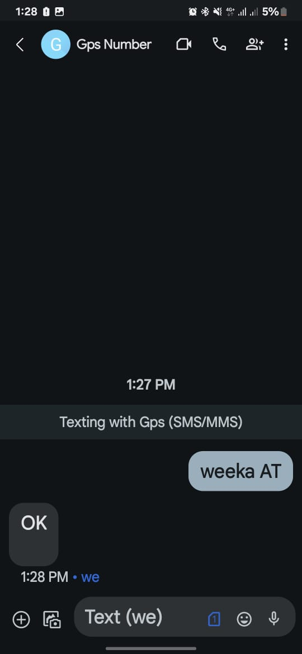Simulate receiving an emergency message and ensure that the Arduino responds correctly.
* Check if it makes a call to the predefined emergency number.
* Verify that it sends an SMS confirmation after managing the emergency.

The results after evaluating the project.

* + 1. First the module sends to the admin a message to unsure it is ready to use :

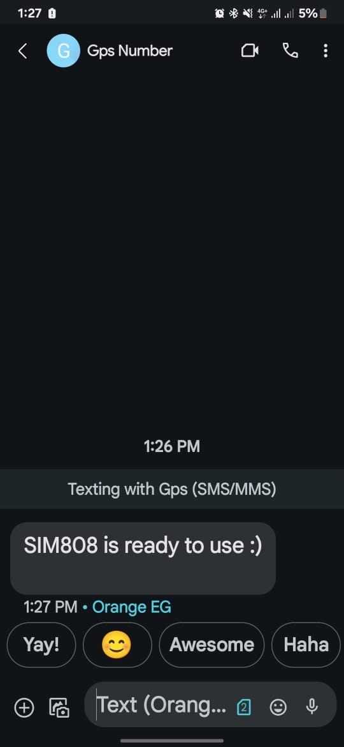

Figure 6 The response of the module.

* + 1. Make a phone call which hangs on 2 seconds to get the GPS data.

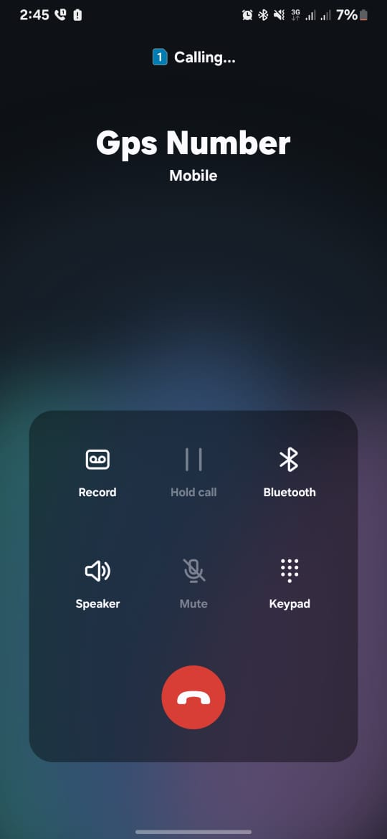

Figure 7 Calling the module.

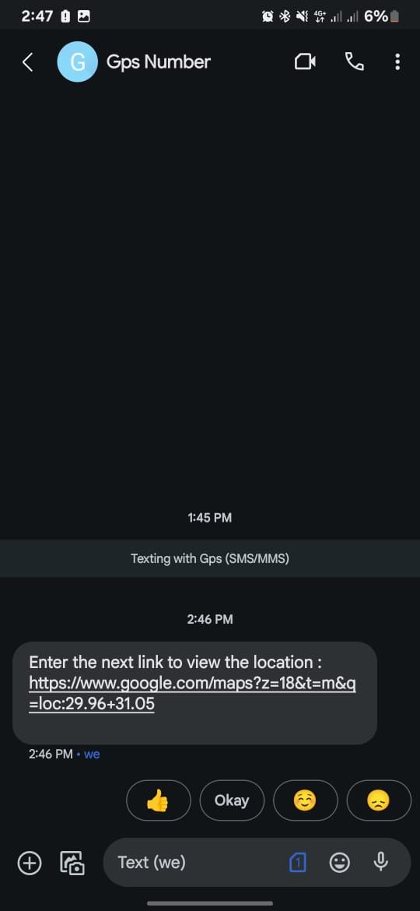

Figure 8 The response of the module.

* + 1. Send various AT commands to the module with the password (**weeka**).
* **Command Syntax**: AT+CGPSSTATUS?

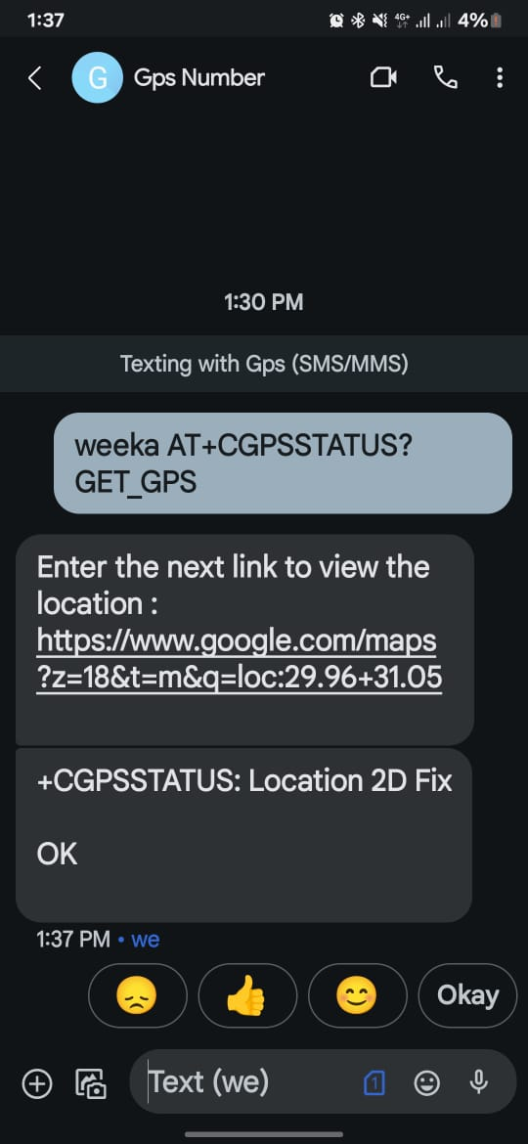

Figure 9 The response of the module.

* **Purpose**: This command is used to check the status of the GPS receiver on the SIM808 module.

GET_GPS is a keyword in the code to get the location.

* **Command Syntax**: ATD<number>;

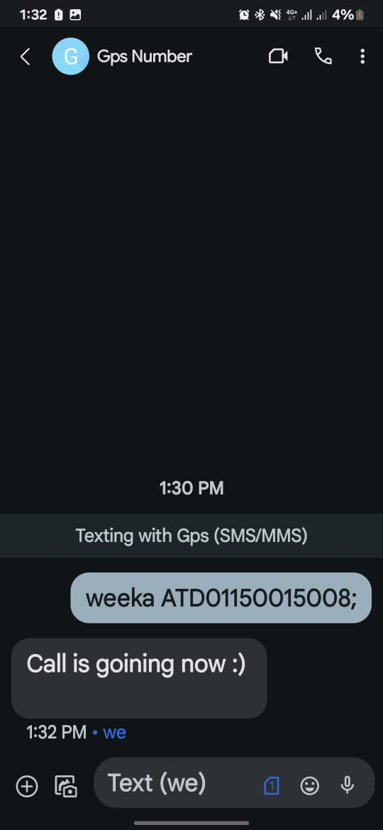

Figure 10 The response of the module.

* **Purpose**: Initiates an outgoing call to the specified phone number.
* **Command Syntax**: AT
* **Purpose**:
* Evaluate Command: The primary purpose of the AT command is to evaluate the communication link between the host device (Arduino) and the modem or module (SIM808). Sending AT prompts the module to respond with an "OK" if the communication link is established and functioning properly.



Figure 11 The response of the module.

* Attention: The command also serves to initiate communication with the module and bring it into command mode. When a modem receives the AT command, it typically switches from data mode (where it might be transmitting or receiving data) to command mode, allowing the host device to issue further commands.
* **Command Syntax**: AT+CGPSPWR=1

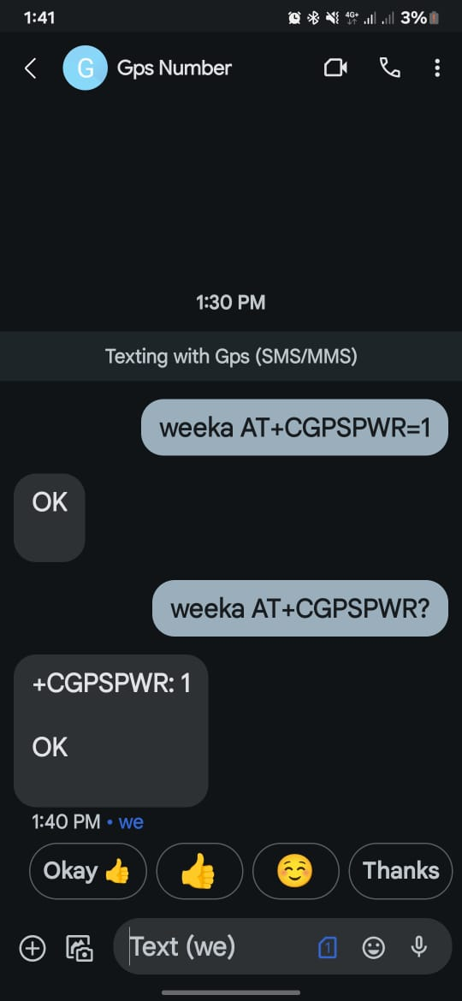

Figure 12 The response of the module.

* **Purpose**:GPS Power Control: The primary purpose of this command is to enable the GPS receiver on the GSM/GPRS module. By sending this command with the parameter 1, you instruct the module to power on the GPS receiver, allowing it to start searching for satellite signals and determining its location.
* **Command Syntax**: AT+CGPSPWR?
* **Purpose**:The primary purpose of the **AT+CGPSPWR?** command is to query the current power state of the GPS receiver in the module. It allows the host device (Arduino) to check whether the GPS receiver is currently powered on or off.
* **Command Syntax**: AT+CGPSPWR=0

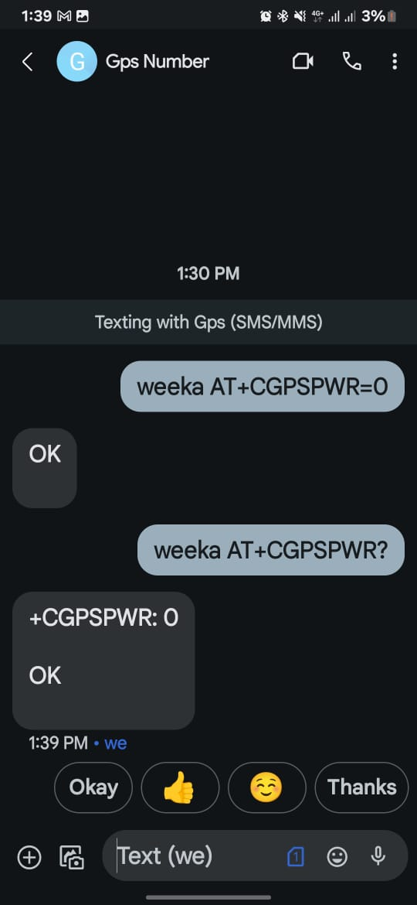

Figure 13 The response of the module.

* **Purpose**:
* The primary purpose of this command is to power off the GPS receiver within the GSM/GPRS module.
* It allows the host device (such as an Arduino) to control the power consumption of the GPS functionality, conserving energy when GPS positioning is not required.

1. Send an emergency message.

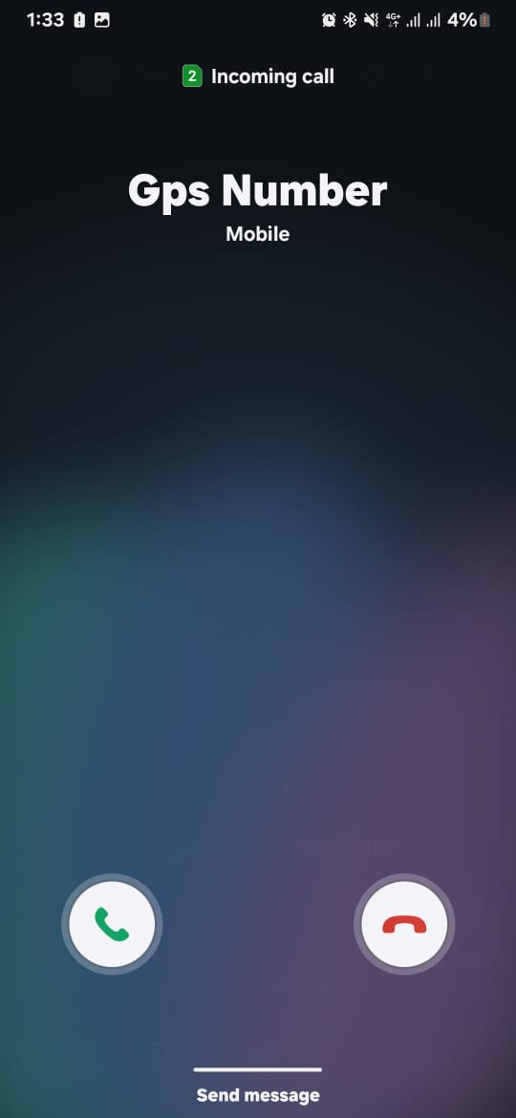

Figure 14 The module calling the emergency number.

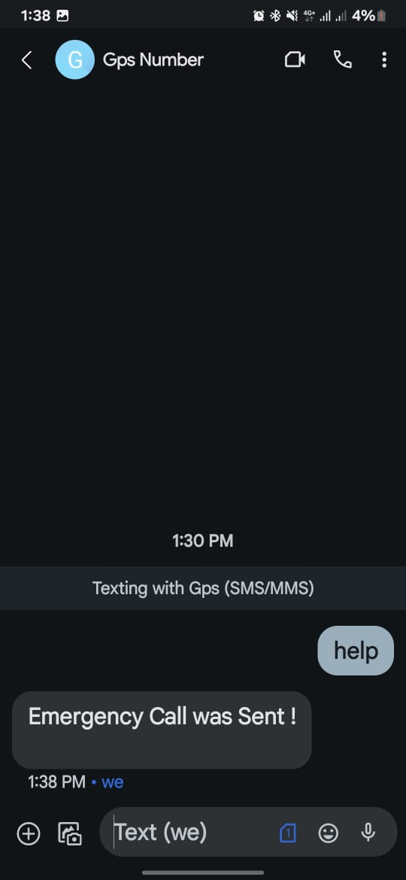

Figure 15 The response of the module.

# Conclusion:

This project utilizes an Arduino board along with a SIM808 module to create a versatile communication and tracking system. The system can send and receive SMS messages using the SIM808 module. It can manage incoming messages, process commands embedded within them, and send responses accordingly.it can be useful for remote control applications or for receiving alerts and notifications.it send it via SMS retrieves GPS data from the SIM808 module, converts it into a google map link and send it via SMS. The system includes an emergency message feature. When it receives a predefined emergency message, it initiates a call to a specified number. This can be invaluable in situations where immediate assistance is required, such as medical emergencies or security incidents. By processing incoming SMS messages, the system can perform predefined actions based on keywords or commands. For example, it can send GPS coordinates upon request, perform specific AT commands.

**Appendix:**

1. Arduino uno features :

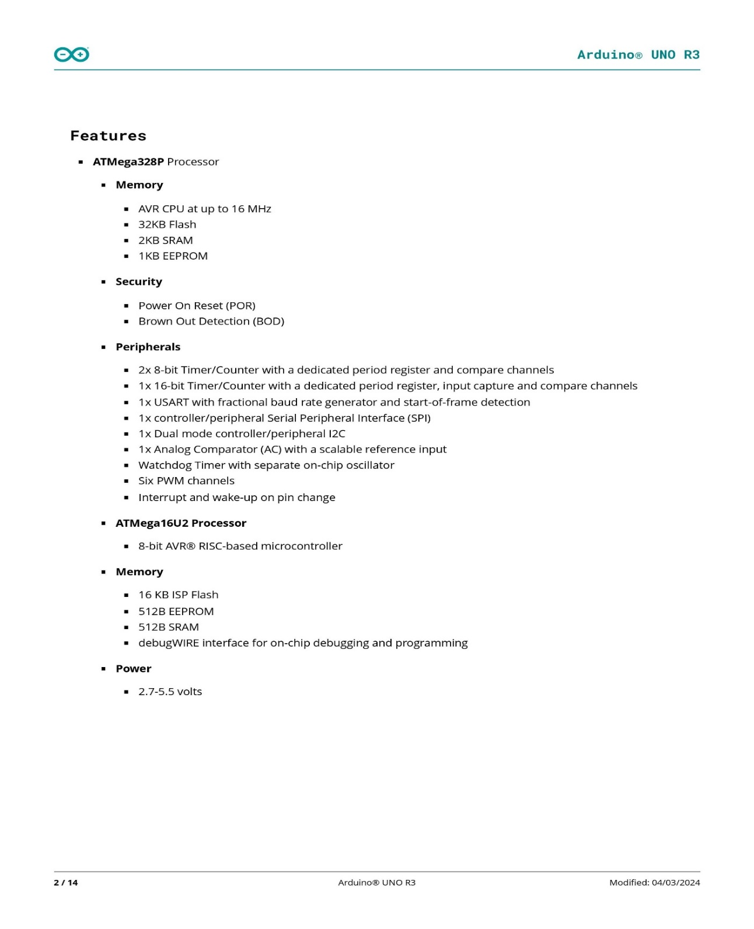

Figure 16 Arduino Uno Features

1. SIM808 Pinout :

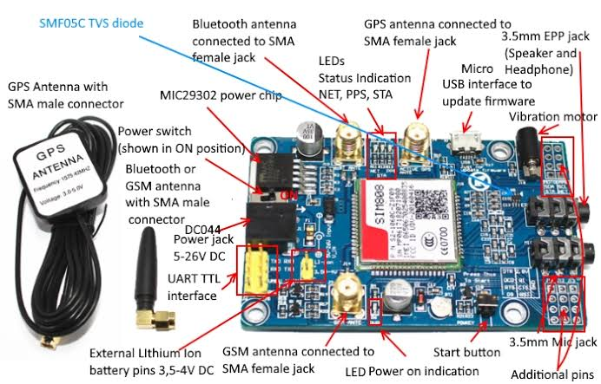

Figure 17 SIM808 description

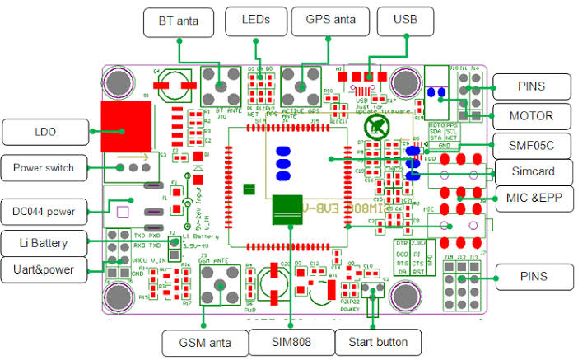

Figure 18 SIM808 description

Here are some tables that explain some of the used AT commands in details :

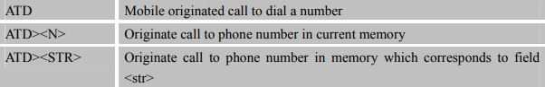

Figure 22 AT command to call phone number.

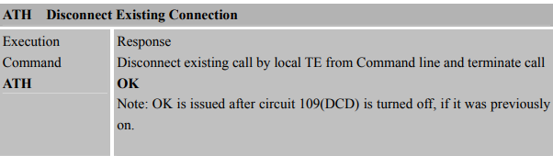

Figure 21 AT commands to disconnect existing connection.

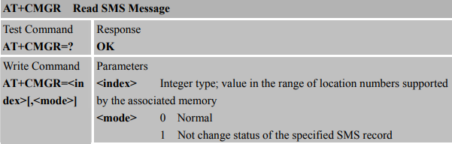

Figure 20 AT commands to read SMS message.

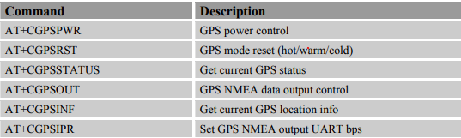

Figure 19 AT Commands for GPS function.

|  |  |
| --- | --- |
| **الكود** | **اسم الطالب** |
| 20200189 | احمد ايمن سيد عبد الحميد |
| 20200273 | احمد طارق فراج محمد |
| 20200004 | سندس رضا عبد المعطى غريب |
| 20200116 | عبد الرحمن شريف علي صقر |
| 20200131 | على اسامة عبيد سيد |
| 20200233 | محمد علاء محمد علي |
| 20200220 | محمد رمضان زكى سعد المصرى |